Generalized Resistance Factor for Flexure

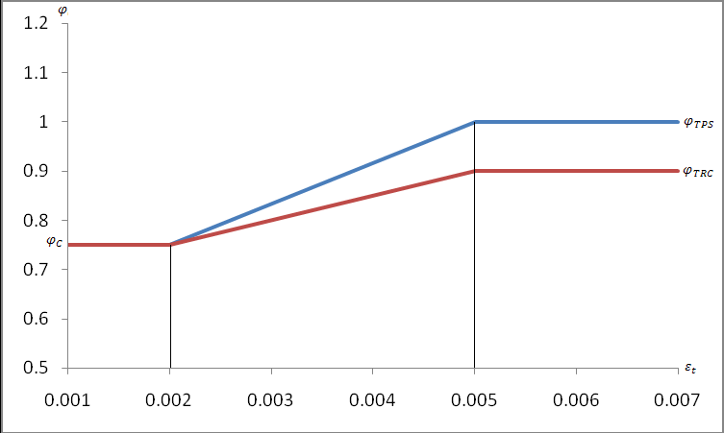

$$ε_{t}=0.003\left(\frac{d_{t}}{c}-1\right)$$

$$φ_{T}=φ_{TRC}+\left(φ_{TPS}-φ_{TRC}\right)PPR$$

|  |  |
| --- | --- |
| $$ε_{t}$$ | Net tensile strain in extreme tension steel at nominal resistance |
| $$d_{t}$$ | Distance from extreme compression fiber to the centroid of extreme tension steel |
| $$φ_{TRC}$$ | Resistance factor for a reinforced concrete tension controlled section |
| $$φ_{TPS}$$ | Resistance factor for a prestressed tension controlled section |
| $$φ_{C}$$ | Resistance factor for a compression controlled section |
| $$φ_{T}$$ | Resistance factor for a partial prestressed tension controlled section |
| PPR | Partial prestress ratio |

$$φ=\left(ε_{t}-0.002\right)\frac{\left(φ_{T}-φ_{C}\right)}{\left(0.003\right)}+φ_{C}$$

$$φ=\left(\frac{d_{t}}{c}-1-\frac{0.002}{0.003}\right)\left(φ_{T}-φ_{C}\right)+φ_{C}$$

$$φ=\left(\frac{d_{t}}{c}-\frac{5}{3}\right)\left(φ_{T}-φ_{C}\right)+φ_{C}$$

$$φ=\left(\frac{d_{t}}{c}-\frac{5}{3}\right)\left(φ_{TRC}+\left(φ_{TPS}-φ_{TRC}\right)PPR-φ_{C}\right)+φ_{C}$$